Name ______________________________________________ Period _____________ Date _________ Mr. Burke
Aim: How do we prepare for tomorrow’s test on circles?

Solve for x.
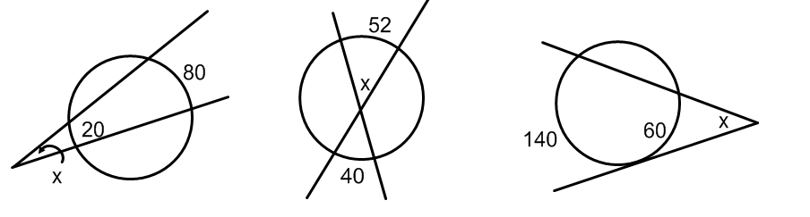

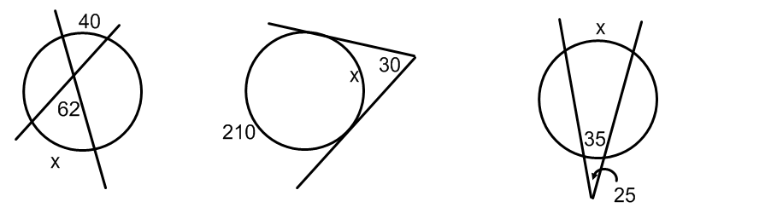

Find the length of the labeled arc:
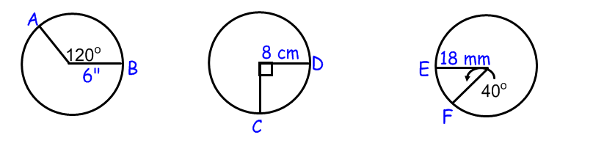

Find the area of the shaded sector:
