
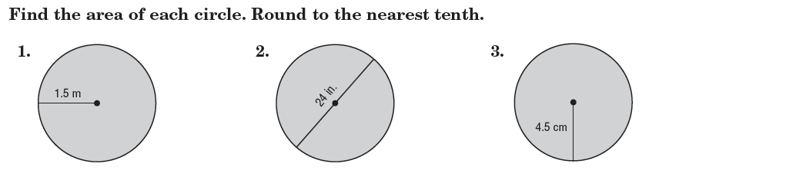

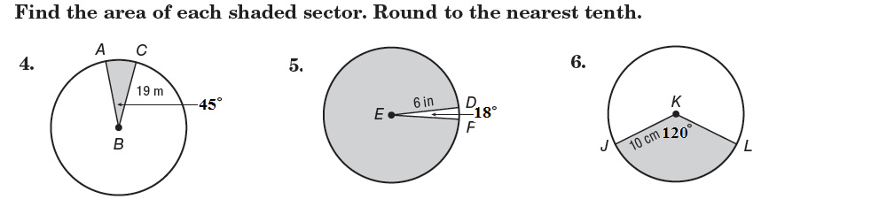

WORD PROBLEMS
7. Sadie wants to draw a clock face on a circular piece of cardboard. If the clock face has a radius of 10 centimeters and is divided into congruent pieces so that each sector is 30 degrees, what is the area of each piece?

8. The hazard sign (below) has a diameter of 8 inches. What is the area of only the black sectors of the sign?


