Name ____________________________________ Period ____________ Date ____________ Mr. Burke
Aim: How do we find the area of circles and squares?

Find the area of the shaded portion of each figure. ALL WORK MUST BE SHOWN!
ROUND ALL ANSWERS TO THE NEAREST TENTH.

1.
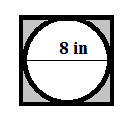

2.Hint: what fraction of the circle is inside the square?
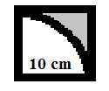

3. Hint: find the area of one circle and multiply by four to get the area of all four circles.
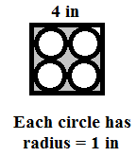

4.
